Lab 4-1 Creating a Slowly Changing Dimension Table
Goals | To create a Slowly Changing Dimension (SCD) table.
Scenario | The dimension table maintains the most recent data and the corresponding SCD table maintains the historical data for the dimension records. You need to create a new SCD table (WC_INDUSTRY_SCD) to maintain the historical data for the dimension records.
Outcome | You have a SCD table to maintain the historical data for the dimension rows of the tracked attributes.
Time | 5 – 10 minutes
Environment | 
Instructions:
- Execute the script to alter an existing table and create a new table and indexes.
  - Select Start > Programs > Microsoft SQL Server > Query Analyzer.
  - In the Connect to SQL Server dialog box, enter the following:
Login name | SIEBEL
Password | SIEBEL
  - Click OK.
  - Select the OLAP database in the database drop-down menu.
  - Select File > Open.
  - In the Open Query File dialog box, navigate to C:\Data\ANADW and select the Create_Industry_SCD_Table.sql file.
  - Click Open. Examine the SQL here. This SQL alters the existing staging table (WC_INDUSTRY_DS) to include columns to support audit trails and creates a new table and indexes to store historical data for the industry dimension data.
  - Select Query > Execute.
  - Ensure that the SQL statement executes correctly. It is okay if you get an error message the first time you execute the SQL statement. Even though the error message tells that it cannot the drop the table, the script created the table in the database. You can execute the SQL statement again to confirm the table is dropped and recreated in the database.
    - In the Query Analyzer window, select Edit > Clear Window.
    - Enter the following:
SELECT *
FROM OLAP..W_INDUSTRY_DS
    - Select Query > Execute
    - Verify SCD_START_DT and SCD_END_DT columns appear.
  - Select File > Exit to close Query Analyzer.
  - Click No to not save the changes.
Lab 4-2 Creating a Source Independent Loading Mapping for SCD
Goals | To create a Source Independent Loading (SIL) mapping to populate the SCD table.
Scenario | The dimension table maintains the most recent data for each fact record. In order to maintain the historical data for the dimension record, you have created a custom slowly changing dimension table. You have to create a SIL mapping to populate and maintain this SCD table.
Outcome | You have a SIL mapping that populates and tracks the changes to dimension records in the corresponding SCD table.
Time | 50 – 60 minutes
Instructions:
- If necessary, start the Informatica Designer tool and connect to the Siebel Informatica repository.
  - Select Start > Programs > Informatica PowerCenter 7.1.2 > Informatica PowerCenter 7.1.2 OEM for Siebel – Client > Designer.
  - Double-click Siebel_DW_Rep.
  - In the Connect to Repository dialog box, enter the following:
Username | Administrator
Password | Administrator
  - Click Connect.
- Import the source you will use to build the mappings.
  - Select the Custom folder and select Tools > Source Analyzer. Verify that the Designer toolbar displays Custom – [Siebel_DW_Rep] in the drop-down field in the upper-left corner.
  - Select Sources > Import from Database. The Import Tables dialog box is displayed.
  - Select the OLAP (SQL Server) ODBC data source from the drop-down list to connect to the target database.
  - Enter the following values:
Username: | SIEBEL
Owner name: | SIEBEL (if <ALL> is not pre-selected)
Password: | SIEBEL
  - Click Connect.
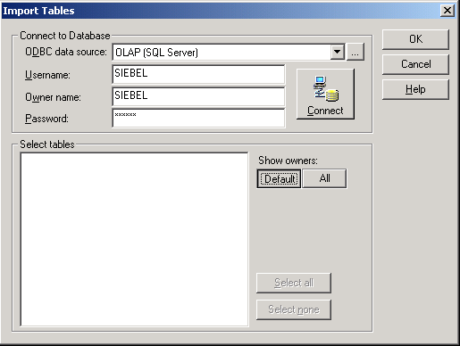
  - Click All.
  - Expand dbo and the TABLES sub-folder.
  - Select the W_INDUSTRY_DS and W_INDUSTRY_D tables to import the source definitions into the repository.
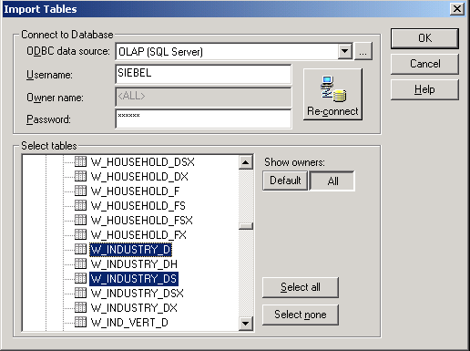
  - Click OK.
  - In the Repository Navigator, expand Custom > Sources > OLAP and verify that the W_INDUSTRY_DS and W_INDUSTRY_D tables appear.
  - Define the database table properties. You are changing the database type from Microsoft SQL Server to Oracle for the imported objects.
    - In the Source Analyzer, double-click the W_INDUSTRY_DS object.
    - Click the Table tab.
    - Click the Database type drop-down list box and change the database type from Microsoft SQL Server to Oracle.
    - Click Apply.
    - Click OK.
    - Repeat the above step for W_INDUSTRY_D source object.
  - Select Repository > Save.
  - In the Output window, verify that the sources were inserted.
- Import the target you will use to build the mappings.
  - Select the Custom folder and select Tools > Warehouse Designer. Verify that the Designer toolbar displays Custom – [Siebel_DW_Rep] in the drop-down field in the upper-left corner.
  - Select Targets > Import from Database. The Import Tables dialog box is displayed.
  - Select the OLAP (SQL Server) ODBC data source from the drop-down list to connect to the target database.
  - Enter the following values:
Username: | SIEBEL
Owner name: | SIEBEL (if <ALL> is not pre-selected)
Password: | SIEBEL
  - Click Connect.
  - Click All.
  - Expand dbo and the TABLES sub-folder.
  - Select the WC_INDUSTRY_SCD table to import the target definition into the repository.
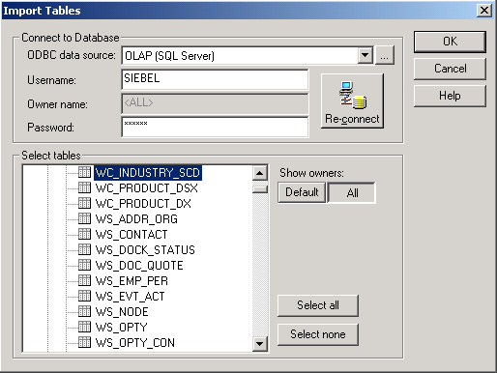
  - Click OK.
  - In the Repository Navigator, expand Custom > Targets and verify that the WC_INDUSTRY_SCD table appears.
  - Define the database table properties. You are changing the database type from Microsoft SQL Server to Oracle and defining the primary keys for the imported object.
    - In the Warehouse Designer, double-click the WC_INDUSTRY_SCD object.
    - Click the Table tab.
    - Click the Database type drop-down list box and change the database type from Microsoft SQL Server to Oracle.
    - Click the Columns tab.
    - Select ROW_WID and select Primary Key as the Key Type using the drop-down list.
    - Select SCD_START_DT_WID and select Primary Key as the Key Type using the drop-down list.
    - Click Apply.
    - Click OK.
  - Select Repository > Save.
  - In the Output window, verify that the target is inserted.
- Create the Source Independent Load mapping, Custom_SIL_IndustryDimension_SCD, using the as-delivered mapping, SIL_PersonDimension_SCD, provided in the SIL folder. This out-of-the-box mapping contains identical extraction, transformation, and loading logic that you can use to build your new SCD mapping. It is easier to leverage an existing auxiliary change capture process mapping and use its business logic and components than to build a new mapping from scratch.
  - Select Tools > Mapping Designer.
  - Expand SIL > Mappings sub-folder.
  - Select SIL_PersonDimension_SCD and select Edit > Copy to copy the mapping.
  - In the Custom folder, expand the Mappings sub-folder.
  - Select Edit > Paste to paste the mapping you just copied.
  - Click Yes in the Copy Confirmation dialog box to copy the mapping.
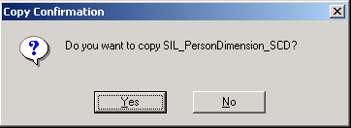
  - Click Finish to close the Copy Wizard dialog box.
- Rename the mapping.
  - Drag and drop the SIL_PersonDimension_SCD mapping into the Mapping Designer window. Click Yes if prompted to close the current mapping.
  - Select Mappings > Edit.
  - In the Edit Mapping dialog box, type Custom_SIL_IndustryDimension_SCD in the Mapping field.
  - Type the following comments The data from OLAP Staging table WC_INDUSTRY_DS is moved over the Slowly Changing Dimension Table WC_INDUSTRY_SCD in the Comments field.
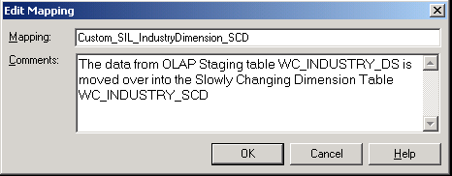
  - Click OK to close the dialog box.
  - Select Repository > Save to save the changes.
- Add and modify source definitions for the mapping.
  - Select W_PERSON_DS and W_PERSON_D source definitions and delete them.
  - Click Yes to confirm the deletions.
  - In the Repository Navigator, expand Custom > Sources > OLAP.
  - Drag and drop the W_INDUSTRY_DS and W_INDUSTRY_D sources into the Mapping Designer window. By default, a new Source Qualifier transformation is created for each new Source Definition.
  - Delete the following source qualifiers: SQ_W_INDUSTRY_DS and SQ_W_PERSON_D.
  - Click Yes to confirm the deletions.
- Modify and link the Source Qualifier transformation. This transformation joins rows from the staging table (W_INDUSTRY_DS) with the dimension table (W_INDUSTRY_D) and uses it to determine and apply slowly changing dimensions.
  - Delete the unnecessary ports from the SQ_W_INDUSTRY_D Source Qualifier transformation.
    - Double-click SQ_W_INDUSTRY_D Source Qualifier.
    - Click the Ports tab in the Edit Transformations dialog box.
    - Select the VERTICAL, ETL_PROC_WID and PAR_INTEGRATION_ID ports.
    - Click the Delete button (with scissors) to delete the ports.
    - Click Apply.
    - Click OK to close the Edit Transformations dialog box.
  - Drag the VERTICAL, SCD_START_DT, and SCD_END_DT columns from W_INDUSTRY_DS Source Definition to blank columns on SQ_W_INDUSTRY_D Source Qualifier.
  - Edit the SQ_W_INDUSTRY_D Source Qualifier transformation’s SQL query to reference the correct tables and columns. You are going to use the SQL Override option to customize the default query.
    - Move SQ_W_INDUSTRY_D Source Qualifier transformation such that it appears to the right of W_INDUSTRY_D source definition.
    - Double-click SQ_W_INDUSTRY_D Source Qualifier
    - In the Edit Transformations dialog box, click Ports tab.
    - Rearrange the ports to look the following. You can use the Move Up and Move Down buttons to move up or down a port. The order of the ports must match the order in which the corresponding columns appear in the SQL override.
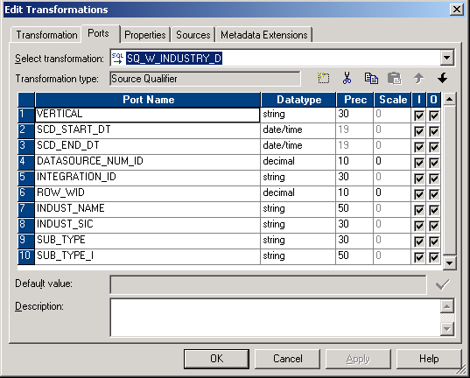
    - In the Edit Transformations dialog box, click the Properties tab.
    - For the Sql Query Transformation Attribute, click the down arrow button in the Value field to open the SQL Editor.
    - Enter the SQL to appear as follows. Examine the SQL carefully. This joins rows from the staging table (W_INDUSTRY_DS) with the dimension table (W_INDUSTRY_D) by INTEGRATION_ID and DATASOURCE_NUM_ID to retrieve the slowly changing column, start date, and end date from the staging table, and all columns from the dimension table.
SELECT
W_INDUSTRY_DS.VERTICAL,
W_INDUSTRY_DS.SCD_START_DT,
W_INDUSTRY_DS.SCD_END_DT,
W_INDUSTRY_D.DATASOURCE_NUM_ID,
W_INDUSTRY_D.INTEGRATION_ID,
W_INDUSTRY_D.ROW_WID,
W_INDUSTRY_D.INDUST_NAME,
W_INDUSTRY_D.INDUST_SIC,
W_INDUSTRY_D.SUB_TYPE,
W_INDUSTRY_D.SUB_TYPE_I
FROM
W_INDUSTRY_DS,
W_INDUSTRY_D
WHERE
W_INDUSTRY_DS.INTEGRATION_ID = W_INDUSTRY_D.INTEGRATION_ID AND
W_INDUSTRY_DS.DATASOURCE_NUM_ID = W_INDUSTRY_D.DATASOURCE_NUM_ID
    - To validate the SQL, enter the following:
ODBC data source | OLAP (SQL Server)
Username: | SIEBEL
Password: | SIEBEL
    - Click Validate. You will see a message “Cannot validate query because there are no valid fields projected from the Source Qualifier”.
    - Click OK.
    - Click OK in the SQL Editor.
    - Click Apply and then OK in the Edit Transformations dialog box.
    - The layout of your mapping should like the below one at this stage.
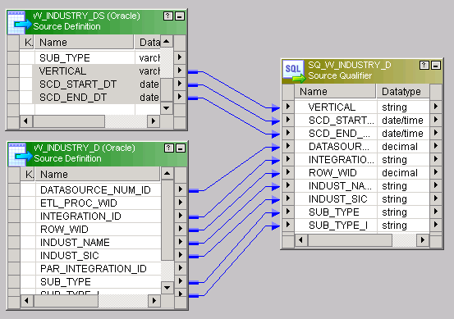
- Modify and link the Expression transformation EXP_DIMENSION_WID.
  - Link the INTEGRATION_ID and DATASOURCE_NUM_ID ports from SQ_W_INDUSTRY_D source qualifier transformation to EXP_DIMENSION_WID expression transformation. You can drag and drop these ports directly from source qualifier transformation on to the Expression transformation.
  - Delete the unnecessary ports from the EXP_DIMENSION_WID expression transformation.
    - Double-click EXP_DIMENSION_WID Expression transformation.
    - Click the Ports tab in the Edit Transformations dialog box.
    - Select the CONTACT_TYPE_I port.
    - Click the Delete button (with scissors) to delete the ports. Do not close the Edit Transformations dialog box.
    - Click Apply.
  - Modify the Expression for ETL_PROC_WID port.
    - Select the ETL_PROC_WID port.
    - Click the down arrow button in the Expression column.
    - Validate the below Formula in the Expression Editor dialog box.
:LKP.LKP_ETL_PROC_WID(1) 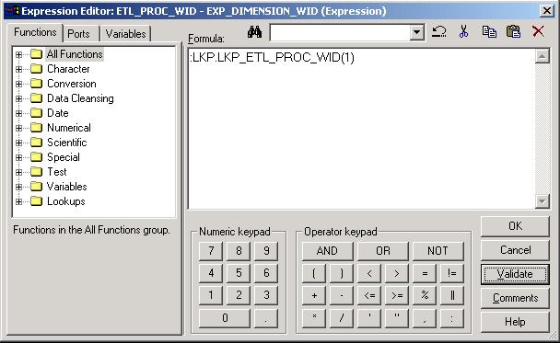
    - Click Validate.
    - Click OK to confirm expression parsed successfully.
    - Click OK to close the Expression Editor.
    - Click OK to close the Edit Transformations dialog box.
- Rename, modify, and link the existing LKP_SCD Lookup Procedure. This transformation queries the slowly changing dimension table to retrieve the dimension row that has been updated.
  - Double-click LKP_SCD Lookup Procedure.
  - In the Description field, type Joining with W_PARAM_G (BASED ON ANALYSIS_END) and with W_INDUSTRY_DS TABLE, based on INTEGRATION_ID and DATASOURCE_NUM_ID, return row_wid, etl_proc_wid, vertical and start date.
  - Edit the ports.
    - Delete the unrelated ports from this lookup procedure.
      - Click the Ports tab of the Edit Transformation dialog box.
      - Delete all the ports except the following. To select multiple ports, you can move the mouse over the number and press Shift+Click to select the ports one at a time or multiple ports at a time. Use the Delete button (with scissors) to delete the ports.
IN_INTEGRATION_ID
IN_DATASOURCE_NUM_ID
DATASOURCE_NUM_ID
ETL_PROC_WID
INTEGRATION_ID
ROW_WID
MARITAL_STAT_CD
SCD_START_DT_WID
SCD_END_DT_WID
    - Modify the port.
      - Select MARITAL_STAT_CD port.
      - Change the MARIAL_STAT_CD port name to VERTICAL.
    - Rearrange the ports to look the following. You can use the Move Up and Move Down buttons to move a port up or down.
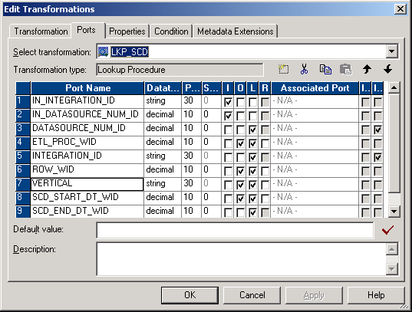
  - Click the Properties tab.
  - For the Lookup table name transformation attribute, change the value to WC_INDUSTRY_SCD.
  - For the Lookup Sql Override transformation attribute, click the down arrow button in the Value field to open the SQL Editor.
  - Enter the following SQL. Examine the Loop SQL Override carefully. It retrieves rows from the slowly changing dimension table (W_INDUSTRY_SCD) for which there are matching rows in the fact staging table (W_INDUSTRY_DS) and global parameter table (W_PARAM_G). These matching rows will be updated in the slowly changing dimension table through subsequent transformations.
SELECT
WC_INDUSTRY_SCD.ETL_PROC_WID as ETL_PROC_WID,
WC_INDUSTRY_SCD.ROW_WID as ROW_WID,
WC_INDUSTRY_SCD.VERTICAL as VERTICAL,
WC_INDUSTRY_SCD.SCD_START_DT_WID as SCD_START_DT_WID,
WC_INDUSTRY_SCD.INTEGRATION_ID as INTEGRATION_ID,
WC_INDUSTRY_SCD.DATASOURCE_NUM_ID as DATASOURCE_NUM_ID
FROM
WC_INDUSTRY_SCD,
W_PARAM_G,
W_INDUSTRY_DS
WHERE
WC_INDUSTRY_SCD.SCD_END_DT_WID = W_PARAM_G.ANALYSIS_END_WID AND
W_INDUSTRY_DS.DATASOURCE_NUM_ID = WC_INDUSTRY_SCD.DATASOURCE_NUM_ID AND
W_INDUSTRY_DS.INTEGRATION_ID = WC_INDUSTRY_SCD.INTEGRATION_ID
  - To validate the SQL, enter the following:
ODBC data source: | OLAP (SQL Server)
Username: | SIEBEL
Password: | SIEBEL
  - Click Validate.
  - Click OK to confirm that no errors were detected.
  - Click OK to close the SQL Editor.
  - Click the Condition tab to verify that the lookup condition is valid. It should compare the INTEGRATION_ID and DATASOURCE_NUM_ID lookup table columns with the IN_INTEGRATION_ID and IN_DATASOURCE_NUM_ID transformation ports. For records meeting the lookup condition, the ETL_PROC_WID, ROW_WID, VERTICAL, and SCD_START_DT_WID will be output.
    - Confirm the following for the INTEGRATION_ID attribute:
Lookup Table Column | INTEGRATION_ID
Operator | =
Transformation Port | IN_INTEGRATION_ID
    - Confirm the following for the DATASOURCE_NUM_ID attribute:
Lookup Table Column | DATASOURCE_NUM_ID
Operator | =
Transformation Port | IN_DATASOURCE_NUM_ID
  - Click Apply.
  - Click OK.
- Modify and link the FIL_ETL_PROC_WID Filter transformation. This transformation filters out rows that have already been inserted or updated when a session is restarted. If the dimension rows’ DATASOURCE_NUM_ID and ETL_PROC_WID column values match that of rows in the slowly changing dimension target table, those rows are filtered out.
  - Rename and delete all unwanted ports.
    - Double-click FIL_ETL_PROC_WID Filter transformation
    - Click the Ports tab.
    - Delete all ports starting from FST_NAME to and including GEO_WID by selecting each port. Use shift-click or control-click to select multiple ports at a time. Use the Delete button (with scissors) to delete the ports
    - Select the LKP_MARITAL_STAT_CD port and change the port name to LKP_VERTICAL.
    - Select the MARITAL_STAT_CD port and change the port name to VERTICAL.
    - Click Apply.
    - Click OK.
  - Link the ports ROW_WID, VERTICAL, SCD_START_DT, and SCD_END_DT from SQ_W_INDUSTRY_D source qualifier transformation to the corresponding ports on FIL_ETL_PROC_WID filter transformation.
  - Drag and drop the ports INDUST_NAME, INDUST_SIC, SUB_TYPE, and SUB_TYPE_I from SQ_W_INDUSTRY_D source qualifier transformation on empty columns on FIL_ETL_PROC_WID filter transformation.
  - Modify properties for FIL_ETL_PROC_WID Filter.
    - Double-click FIL_ETL_PROC_WID Filter.
    - Click the Properties tab.
    - For the Filter Condition transformation attribute, click the down arrow button in the Value field to open the Expression Editor.
    - Validate the below Formula. This SQL only allows records that are not already inserted or updated in the current ETL session or records whose existing ETL_PROC_WIDs are null.
ISNULL(LKP_ETL_PROC_WID) OR (ETL_PROC_WID!=LKP_ETL_PROC_WID)
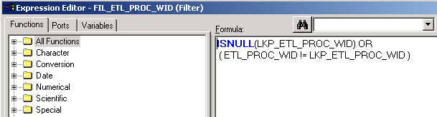
    - Click Validate.
    - Click OK to confirm that the expression parsed successfully.
    - Click OK to close Expression Editor.
    - Click OK.
- Modify and link the Expression transformation EXP_MATCH_FLG.
  - Rename the ports.
    - Double-click EXP_MATCH_FLG Expression transformation.
    - Click the Ports tab in the Edit Transformations dialog box.
    - Select the LKP_MARITAL_STAT_CD port and change the port name to LKP_VERTICAL.
    - Select the MARITAL_STAT_CD port and change the port name to VERTICAL.
  - Modify the Expression for ETL_PROC_WID port.
    - Select the MATCH_FLG port.
    - Click the down arrow button in the Expression column.
    - Validate the below formula in the Expression Editor dialog box.
IIF((ISNULL(LKP_VERTICAL) AND ISNULL(VERTICAL)) OR
(LKP_VERTICAL = VERTICAL), 'YES','NO')
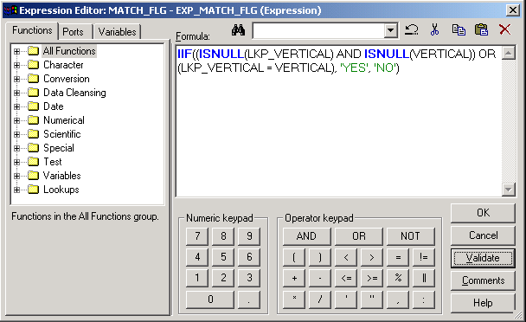
    - Click Validate.
    - Click OK to confirm expression parsed successfully.
    - Click OK.
    - Click Apply to save the changes
    - Click OK.
- Verify the links to the Mapplet transformation MPLT_SCD.
  - Verify the port MATCH_FLG from EXP_MATCH_FLG Expression transformation is linked to the corresponding input port on MPLT_SCD Mapplet transformation.
  - Verify the Ports LKPSCD_ROW_WID, LKP_SCD_START_DT_WID, SCD_START_DT, and SCD_END_DT from FIL_ETL_PROC_WID Filter transformation are linked to the corresponding input ports on MPLT_SCD Mapplet transformation.
- Modify and link the Expression transformation EXP_GATHER.
  - Rename and delete all unwanted ports.
    - Double-click EXP_GATHER Expression transformation.
    - Click the Ports tab in the Edit Transformations dialog box.
    - Delete all ports starting from LOGIN to and including LAST_NAME, SEX_MF to and including ACCNT_ID, and GEO_WID by selecting each port. To delete multiple ports, you can move the mouse over the number and press Shift+Click the ports one at a time or multiple at a time. Use the Delete button (with scissors) to delete the ports
    - Select the MARITAL_STAT_CD port and change the port name to VERTICAL.
    - Click Apply.
    - Click OK.
  - Drag and drop the ports INDUST_NAME, INDUST_SIC, SUB_TYPE, and SUB_TYPE_I from FIL_ETL_PROC_WID Filter transformation on empty columns on EXP_GATHER Expression transformation.
- Modify and link the Update Strategy transformation UPD_INS_SCD.
  - Drag and drop the ports INDUST_NAME, INDUST_SIC, SUB_TYPE, and SUB_TYPE_I from EXP_GATHER to empty columns on UPD_INS_SCD. Ensure that you do not connect these ports to the pre-existing columns in the Update Strategy transformation.
  - Rename and delete all unwanted ports.
    - Double-click UPD_INS_SCD Update Strategy transformation.
    - Click the Ports tab in the Edit Transformations dialog box.
    - Delete all ports starting from LOGIN to LAST_NAME, SEX_MF to ACCNT_ID, and FULL_NAME to GEO_WID by selecting each port. To delete multiple ports, you can move the mouse over the number and press Shift+Click the ports one at a time or multiple at a time. Use the Delete button (with scissors) to delete the ports.
    - Select the MARITAL_STAT_CD port and change the port name to VERTICAL.
  - Click the Properties tab.
  - For the Update Strategy Expression transformation attribute, click the down arrow button in Value field to open the Expression Editor.
  - Confirm the existence of the below formula. The Update Strategy transformation flags to update all the changed dimension rows with the new end date (SCD_END_DT_WID).
IIF(INSERT_UPDATE_FLAG = 'INSERT', DD_INSERT, DD_UPDATE)
  - Click Validate to validate the Update Strategy Expression:
  - Click OK to confirm that the expression parsed successfully.
  - Click OK to close the Expression Editor.
  - Click OK.
- Add and link the target definition. You are including the target slowly changing dimension table (WC_INDUSTRY_SCD) to this mapping.
  - Delete W_PERSON_SCD Target Definition.
  - Click Yes to confirm the deletion.
  - In the Repository Navigator, expand Custom > Targets and drag WC_INDUSTRY_SCD into the Mapping Designer.
  - Link the following columns from UPD_INS_SCD Update Strategy transformation to WC_INDUSTRY_SCD Target Definition.
UPD_INS_SCD  Update Strategy Transformation | WC_INDUSTRY_SCD  Target Definition
ROW_WID | ROW_WID
INTEGRATION_ID | INTEGRATION_ID
DATASOURCE_NUM_ID | DATASOURCE_NUM_ID
ETL_PROC_WID | ETL_PROC_WID
VERTICAL | VERTICAL
START_DT__WID | SCD_START_DT_WID
END_DT_WID | SCD_END_DT_WID
INDUST_NAME | INDUST_NAME
INDUST_SIC | INDUST_SIC
SUB_TYPE | SUB_TYPE
SUB_TYPE_I | SUB_TYPE_I
- Confirm the mapping layout.
  - The part of the mapping layout that inserts new records and updates existing records is shown below.
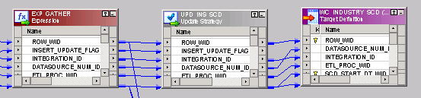
- Modify and link the FIL_END_DT Filter transformation. This filter transformation allows rows that update the effective end date of the current row in the Slowly Changing Dimension as of last ETL.
  - Confirm the ports from EXP_GATHER Expression transformation are all correctly linked to FIL_END_DT Filter transformation.
EXP_GATHER  Expression Transformation | FIL_END_DT  Filter Transformation
UPDATE_END_DT_FLAG | UPDATE_END_DT_FLAG
END_DT_WID_FOR_UPDATE_SCDLASTROW | END_DT_WID_FOR_UPDATE_SCDLASTROW
START_DT_WID_FOR_UPDATE_SCDLASTROW | START_DT_WID_FOR_UPDATE_SCDLASTROW
ROW_WID | ROW_WID
  - Confirm the filter properties for FIL_END_DT Filter.
    - Double-click FIL_END_DT Filter.
    - Click the Properties tab.
    - For the Filter Condition transformation attribute, click the down arrow button in the Value field to open the Expression Editor.
    - Confirm the below Formula. This SQL only allows rows that update the effective end date of the current row in the Slowly Changing Dimension as of last ETL.
UPDATE_END_DT_FLAG = 'UPDATE'
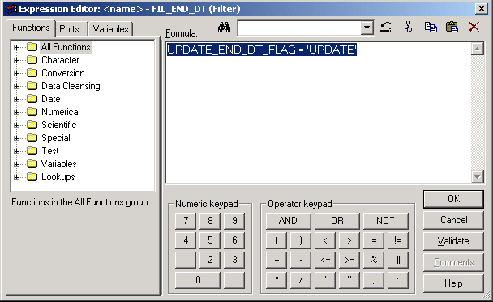
    - Click Validate.
    - Click OK to confirm that the expression parsed successfully.
    - Click OK to close Expression Editor.
    - Click OK.
- Modify and link the Update Strategy transformation UPD_end_dt.
  - Confirm the ports from FIL_END_DT Filter transformation are all correctly linked to UPD_end_dt Update Strategy transformation.
FIL_END_DT  Filter Transformation | UPD_end_dt  Update Strategy Transformation
END_DT_WID_FOR_UPDATE_SCDLASTROW | END_DT_WID_FOR_UPDATE_SCDLASTROW
START_DT_WID_FOR_UPDATE_SCDLASTROW | START_DT_WID_FOR_UPDATE_SCDLASTROW
ROW_WID | LKP_SCD_ROW_WID
  - Modify the ports for UPD_end_dt.
    - Double-click UPD_end_dt.
    - Click the Properties tab.
    - For the Update Strategy Expression transformation attribute, click the down arrow button in Value field to open the Expression Editor.
    - Confirm the existence of the below formula. The Update Strategy transformation flags to update the changed dimension rows with the new end date (SCD_END_DT_WID).
DD_UPDATE
    - Click Validate to validate the Update Strategy Expression:
    - Click OK to confirm that the expression parsed successfully.
    - Click OK to close the Expression Editor.
    - Click OK.
- Add and link the target definition. You are including the target slowly changing dimension table (WC_INDUSTRY_SCD) to this mapping.
  - Delete W_PERSON_SCD_UPDATE_END_DT Target Definition.
  - Click Yes to confirm the deletion.
  - In the Repository Navigator, expand Custom > Targets and drag WC_INDUSTRY_SCD into the Mapping Designer. Since there is another target with the same name, the Informatica Mapping Designer assigned it a new name.
  - Double-click WC_INDUSTRY_SCD1.
  - In the Transformation tab, click Rename.
  - Type WC_INDUSTRY_SCD_UPDATE_END_DT as the Transformation name.
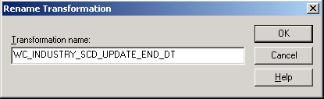
  - Click OK to close the Rename Transformation dialog box.
  - Click Apply.
  - Click OK to close the Edit Transformations dialog box.
  - Link the following columns from UPD_end_dt Update Strategy transformation to WC_INDUSTRY_SCD_UPDATE_END_DT Target Definition.
UPD_end_dt  Update Strategy Transformation | WC_INDUSTRY_SCD_UPDATE_END_DT  Target Definition
START_DT_WID_FOR_UPDATE_SCDLASTROW | SCD_START_DT_WID
LKP_SCD_ROW_WID | ROW_WID
END_DT_WID_FOR_UPDATE_SCDLASTROW | SCD_END_DT_WID
- Validate your work and update the repository.
  - The part of the mapping that inserts new records and updates existing records into one instance of target and that updates the dimension records with the new end date is shown below. Verify that this portion of your mapping looks similar and contains all the objects at this stage.
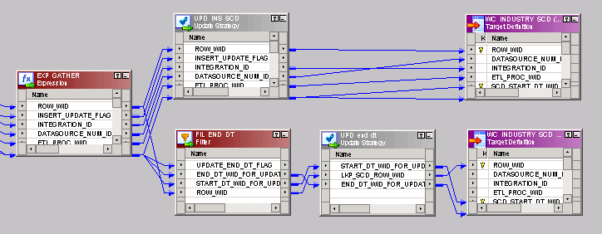
  - View the mapping layout.
    - Select Layout > Arrange.
    - Select both WC_INDUSTRY_SCD and WC_INDUSTRY_SCD_UPDATE_END_DT as the targets and Iconic check box.
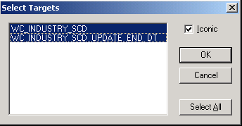
  - Click OK.
  - The entire mapping is shown below. The individual elements of the mapping may not be clear but this layout should help you confirm your mapping design.
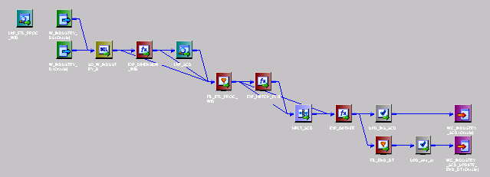
  - If necessary, select View > Output to view the Output window.
  - Click the Validate tab of the Output window and select Mappings > Validate to verify that there are no inconsistencies in the new mapping. You should get a message similar to the following:
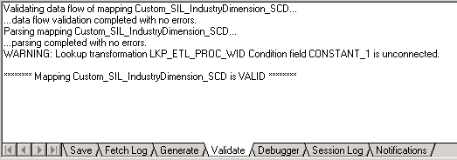
  - If your mapping is valid, select Repository > Save to update the repository.
Lab 4-3 Adding Sessions and Workflows
Goals | To create sessions and workflows in the Custom folder of the Informatica repository for the SIL mapping you created in the previous lab.
Scenario | You have built the mapping to load data into the WC_INDUSTRY_SCD slowly changing dimension table in the SRMW. You have to create sessions and workflows in Informatica Workflow Manager to run this mapping.
Outcome | You have sessions and workflows associated with the SIL mapping and have loaded the SCD table (WC_INDUSTRY_SCD).
Time | 10 – 15 minutes
Instructions:
- If necessary, start the Informatica Workflow Manager tool and connect to the Siebel Informatica repository.
  - Select Start > Programs > Informatica PowerCenter 7.1.2 > Informatica PowerCenter 7.1.2 OEM for Siebel – Client > Workflow Manager.
  - Double-click Siebel_DW_Rep.
  - In the Connect to Repository dialog box, enter the following:
Username: | Administrator
Password: | Administrator
  - Click Connect.
- Create the workflow Custom_SIL_IndustryDimension_SCD in the Custom folder for the SIL mapping you created. This workflow contains instructions on how to execute the session task for the Custom_SIL_IndustryDimension_SCD mapping that extracts and moves the data from the source tables, W_INDUSTRY_D and W_INDUSTRY_DS, to the target slowly changing dimension table, WC_INDUSTRY_SCD.
  - Double-click Custom to expand the folder.
  - Select Tools > Workflow Designer.
  - Select Workflows > Create.
  - Click Yes to acknowledge that the existing workflow will be closed.
  - In the Create Workflow dialog box, type the name Custom_SIL_IndustryDimension_SCD.
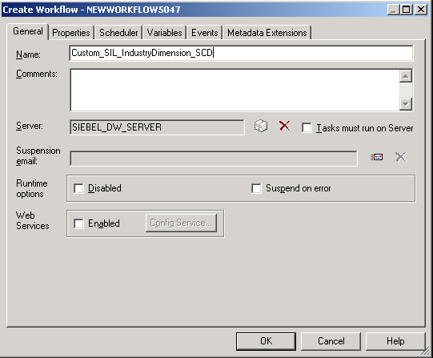
  - Click OK.
  - Select Tasks > Create to add a session to the workflow.
  - In the Create Task dialog box, select Session type task.
  - Type the name Custom_SIL_IndustryDimension_SCD.
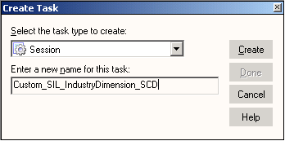
  - Click Create.
  - In the Mappings dialog box, select the Custom_SIL_IndustryDimension_SCD mapping.
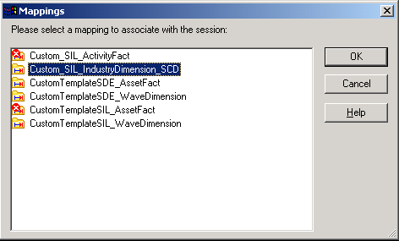
  - Click OK.
  - Click Done to close the Create Task dialog box.
  - In the Workflow Designer window, drag the session off of the Start task such that both Start and the newly created Session tasks are visible.
  - Select Tasks > Link task, then click the Start task and drag the link to the Custom_SIL_IndustryDimension_SCD session.
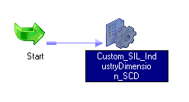
  - Edit the session properties.
    - Double-click the Custom_SIL_IndustryDimension_SCD session.
    - In the General tab, click the Fail parent if this task fails and Fail parent if this task does not run options.
    - Click the Properties tab of the Edit Tasks dialog box.
    - In the $Source connection value attribute, click the down-arrow to open the Connection Browser.
    - In the Connection Browser, select MSSQL_OLAP and click OK.
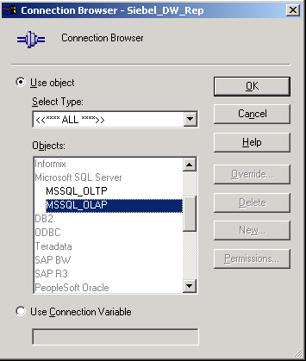
    - In the $Target connection value attribute, click the down-arrow to open the Connection Browser.
    - In the Connection Browser, select MSSQL_OLAP and click OK.
    - Click the Config Object tab of the Edit Tasks dialog box.
    - Click the lower Error handling tab.
    - For the Stop on errors attribute, type a value of 1.
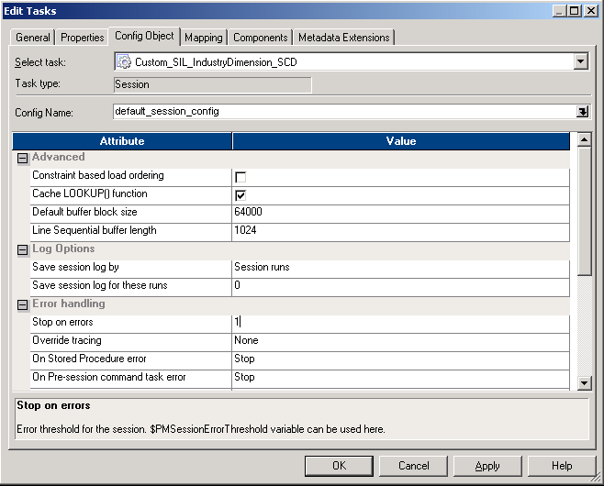
    - Click the Mapping tab of the Edit Tasks dialog box.
    - In the Transformations view on the left pane, select Sources node and then SQ_W_INDUSTRY_D source.
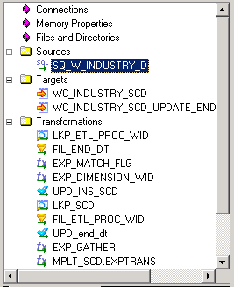
    - In the Connection settings in the right pane for the SQ_W_INDUSTRY_D instance, click the down-arrow button in the Value property to edit its source connection.
    - In the Relational Connection Browser, select MSSQL_OLAP and click OK.
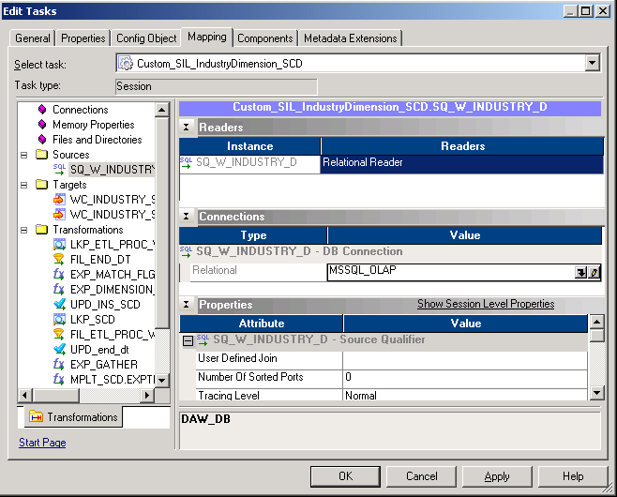
    - In the Transformations view on the left pane, select Targets node and then WC_INDUSTRY_SCD target.
    - In the Connection settings on the right pane for the WC_INDUSTRY_SCD instance, click the down-arrow button in the Value property to edit its target connection.
    - In the Relational Connection Browser, select MSSQL_OLAP and click OK.
    - Select the Target load type attribute from Bulk to Normal.
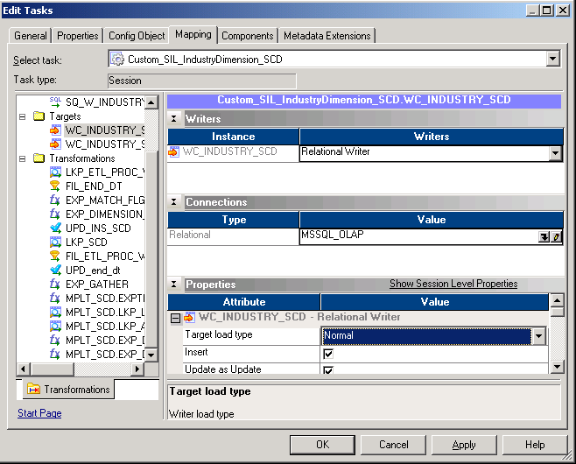
    - Select Targets > WC_INDUSTRY_SCD_UPDATE_END_DT target instance.
    - In the Connection settings on the right pane for the WC_INDUSTRY_SCD_UPDATE_END_DT instance, click the down-arrow button in the Value property to edit its target connection.
    - In the Relational Connection Browser, select MSSQL_OLAP and click OK.
    - Select the Target load type attribute from Bulk to Normal.
    - Click Apply.
    - Click OK.
  - Select Repository > Save.
  - Verify that Custom_SIL_IndustryDimension_SCD workflow is valid in the output window.
- Before running the workflow, query the WC_INDUSTRY_SCD target table to confirm there is no data. WC_INDUSTRY_SCD is the target fact table in the data warehouse that will be populated by running the workflow Custom_SIL_IndustryDimension_SCD you just created.
  - If necessary, start Query Analyzer.
    - Select Start > Programs > Microsoft SQL Server > Query Analyzer.
    - In the Connect to SQL Server dialog box, enter the following:
Login name | SIEBEL
Password | SIEBEL
    - Click OK.
  - In the Query window enter the following:
SELECT COUNT(*)
FROM OLAP..WC_INDUSTRY_SCD
  - Select Query > Execute.
  - Verify that there is no data in WC_INDUSTRY_SCD (returns zero rows).
  - Leave the Query Analyzer running.
- Execute the workflow from the Informatica Workflow Manager to load the data.
  - In Informatica, expand Custom > Workflows > Custom_SIL_IndustryDimension_SCD.
  - Right-click Custom_SIL_IndustryDimension_SCD and select Start Workflow.
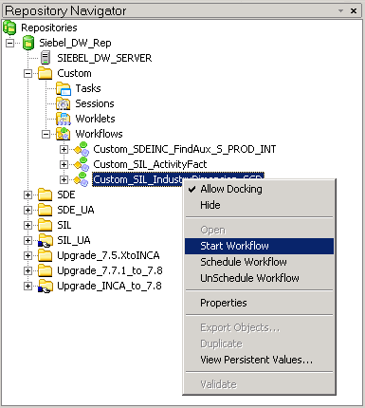
  - Monitor the progress of the session.
    - If Workflow Monitor does not open automatically, double-click the Workflow Monitor icon in the Task Tray.
    - Select the Task View tab.
    - Monitor the progress and verify that the workflow and the session have a status of Succeeded before continuing.
    - When the session has completed, close the Workflow Monitor.
- Query the WC_INDUSTRY_SCD table to verify that the data has been loaded.
  - In the Query Analyzer window enter the following:
SELECT COUNT(*)
FROM OLAP..WC_INDUSTRY_SCD
  - Select Query > Execute.
  - Your count result should be 1,119. If you did not get this row count, ask your instructor for assistance.
Lab 4-4 Configuring the DAC
Goals | To configure the DAC to load the SCD table.
Scenario | You have built the mapping, workflow, and session, and are now prepared to create the task, table group, subject area, and execution plan in DAC to execute them.
Outcome | The DAC is configured to load the SCD table.
Time | 15 – 20 minutes
Instructions:
- Start the DAC server by selecting Start >Programs > Siebel Analytics > Siebel DAC > DAC Server.
- Log into the DAC client.
  - Select Start > Programs > Siebel Analytics > Siebel DAC > DAC Client.
  - In the Login dialog box, enter the following and click Login:
Table owner name | SIEBEL
Password | SIEBEL
  - Confirm the DAC client is connected to the DAC server by looking at the Server Monitor icon. The Server Monitor is located in the upper-right corner of the DAC client and should resemble an orange electrical plug in a socket.
- Import the database tables.
  - Select Views > Design > Tables in the DAC toolbar.
  - Select M_10A_ORG_D or any other record and right-click, then select Import Database Tables.
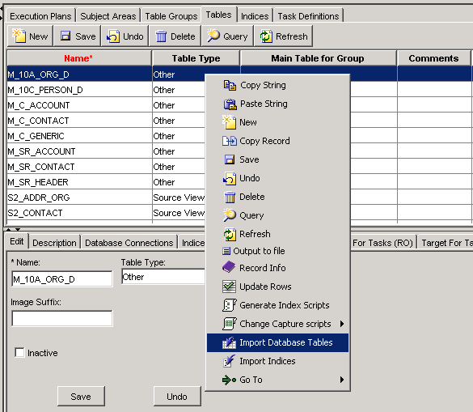
  - In the Importing Database Tables dialog box, select OLAP as the datasource from the drop-down list box, type WC_INDUSTRY_SCD as the name, and click OK.
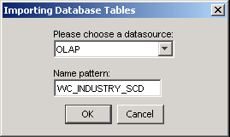
  - Select the Import table check box for the WC_INDUSTRY_SCD record.
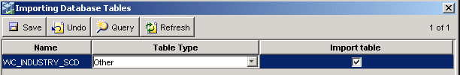
  - Click OK.
  - Click Yes to proceed to import the tables.
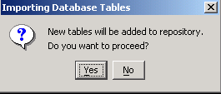
  - In the Tables tab, click Query.
  - Type WC_INDUSTRY_SCD in the Name column.
  - Click Go.
  - Change the Table Type from Other to Slowly Changing Dimension.
  - Click Save.
- Import the table indices.
  - Right-click WC_INDUSTRY_SCD table, then select Import Indices.
  - Select OLAP as the datasource from the drop-down list box and click OK.
  - Check the Merge option for all the records.
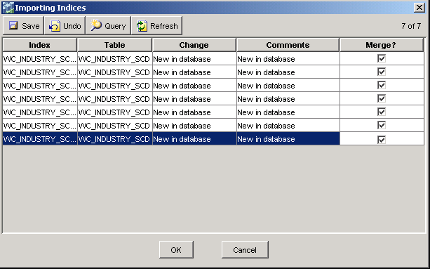
  - Click OK.
  - Click Yes to proceed to import the indices.
- Create a new task to run the Source Independent Load workflow you created to load the slowly changing dimension table.
  - Create a new task.
    - Select Task Definitions.
    - Select the Load SCD into Person Dimension task in the list. Use the Query feature if necessary to locate this task in the list.
    - Right-click the task and select Copy Record.
    - Select the Load SCD into Person Dimension (2) task you created.
    - In the Edit tab of the bottom pane, enter or confirm the following. Since this task populates the main table, Truncate For Full Load should only be selected to ensure the table is emptied during the full ETL load but not during incremental ETL loads.
Name | Custom Load SCD into Industry Dimension
Folder Name | Custom
Source DB | OLAP
Target DB | OLAP
Task Phase | Slowly Changing Dimension
Execution Type | Informatica
Priority | 5
Truncate For Full Load | Selected
Truncate Always | Not Selected
    - Click the Picklist icon in the Command for Incremental Load field.
    - Click Import Sessions command button.
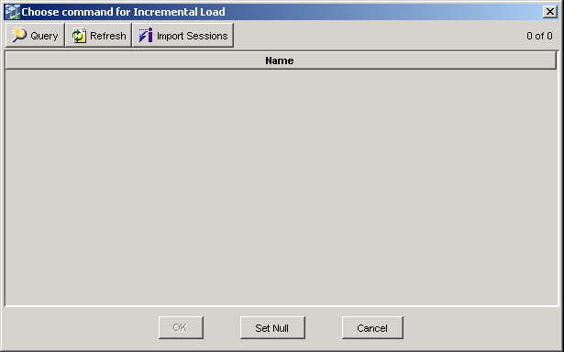
    - In the Importing Informatica Sessions dialog box, select the OLAP datasource from the drop-down list box and click OK.
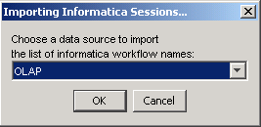
    - Click OK.
    - In the Choose command for Incremental Load window, select Custom_SIL_IndustryDimension_SCD.
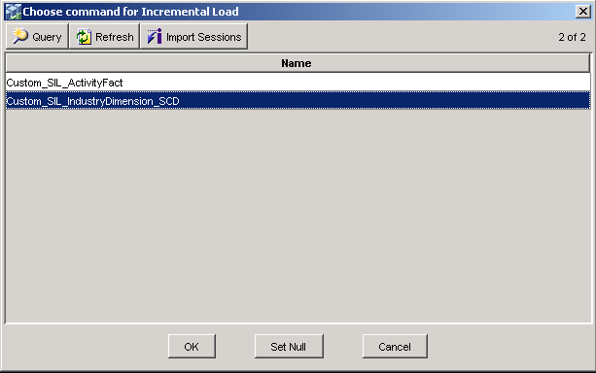
    - Click OK.
    - Click the Picklist icon in the Command for Full Load field.
    - In the Choose command for Full Load window, select Custom_SIL_IndustryDimension_SCD.
    - Click OK.
    - Click Save.
  - Add the source tables for the newly created task.
    - Click the Source Tables tab.
    - Click Edit to open the Choose Source Tables window.
    - Click Remove All to remove all the existing source tables.
    - Click the Query button in Choose Source Tables window, type W_PARAM_G or W_INDUSTRY_D or W_INDUSTRY_DS or WC_INDUSTRY_SCD. The ‘or’ is the conditional clause.
    - Click Go.
    - Click Add All.
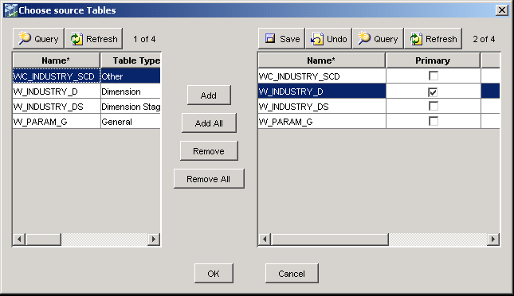
    - Check the Primary flag for W_INDUSTRY_D table.
    - Click Save.
    - Click OK to close the Choose source Tables dialog box.
  - Add the target tables.
    - Click the Target Tables tab.
    - Click Edit to open the Choose Target Tables window.
    - Click Remove All to remove all the existing source tables.
    - Click the Query button in Choose Target Tables window, type WC_INDUSTRY_SCD.
    - Click Go.
    - Click Add All.
    - Check the Primary flag for WC_INDUSTRY_SCD table.
    - Click Save.
    - Click OK to close the Choose target Tables dialog box.
  - Set the dependencies for the Load into SCD Industry Dimension task. This task depends on the Extract for Industry Dimension and Load into Industry Dimension task because it needs the data to be present both in the staging dimension and dimension tables.
    - Click the Depends on Tasks tab.
    - Click Edit to open the Choose Tasks to depend on window.
    - Click Remove All.
    - Click Query, type *Industry Dimension*, and click Go in the left-hand list.
    - Select Extract for Industry Dimension and Load into Industry Dimension in the left-hand list.
    - Click Add.
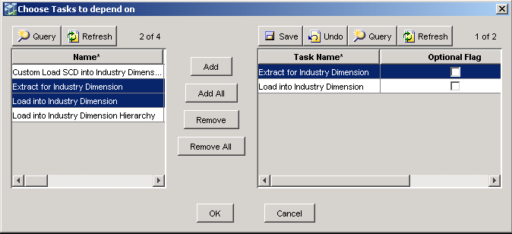
    - Click Save.
    - Click OK to close the Choose Tasks window.
- Add the WC_INDUSTRY_SCD to the INDUSTRY DIMENSION GROUP to ensure that the custom workflows and tasks you created will be run in the right order. You want the WC_INDUSTRY_SCD table loaded in the same ETL as the Industry Dimension table is loaded.
  - Click the Table Groups Top Pane tab while still in the Design view.
  - Query for INDUSTRY DIMENSION GROUP.
  - Click the Tables tab in the bottom pane.
  - Click Edit to open the Choose Tables dialog box.
  - Click Query, type WC_INDUSTRY_SCD, and click Go.
  - Click Add.
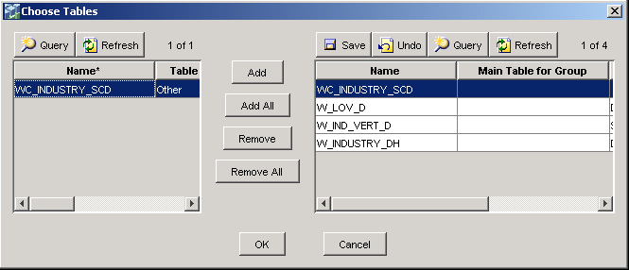
  - Click Save.
  - Click OK.
- Create a new subject area and include the table group you created in the previous step.
  - Select Views > Design > Subject Areas.
  - Select the Forecast Subject Area subject area in the list. Use the Query feature if necessary to locate this subject area from the list.
  - Right-click the subject area and select Copy Record.
  - Select the Forecast Subject Area (2) subject area you created.
  - In the Edit tab of the bottom pane, enter Custom Industry Subject Area as the subject area name.
  - Click Save.
  - Click the Table Groups bottom pane while Custom Industry Subject Area record is selected on the top pane.
  - Click Edit to open the Choose Table Groups dialog box.
  - Click Remove All.
  - Click Query, type *INDUSTRY DIMENSION*, and click Go in the left-hand list.
  - Select INDUSTRY DIMENSION GROUP in the left-hand list.
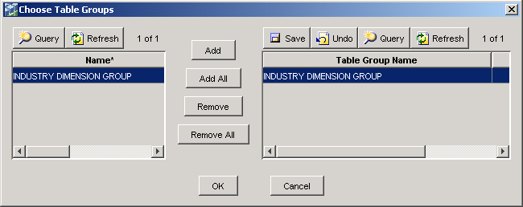
  - Click Add.
  - Click Save.
  - Click OK to close the Choose Tasks window.
- Create a new execution plan and include the subject area you created in the previous step.
  - Select Views > Design > Execution Plans.
  - Select the Sales execution plan in the list. Use the Query feature if necessary to locate this execution plan from the list.
  - Right-click the subject area and select Copy Record.
  - Select the Sales (2) subject area you created.
  - In the Edit tab of the bottom pane, enter Custom Industry as the execution plan name.
  - Click Save.
  - Click OK.
  - Click the Subject Areas bottom pane while Custom Industry record is selected on the top pane.
  - Click Edit to open the Choose Subject Areas dialog box.
  - Click Remove All.
  - Select Custom Industry Subject Area in the left-hand list.
  - Click Add.
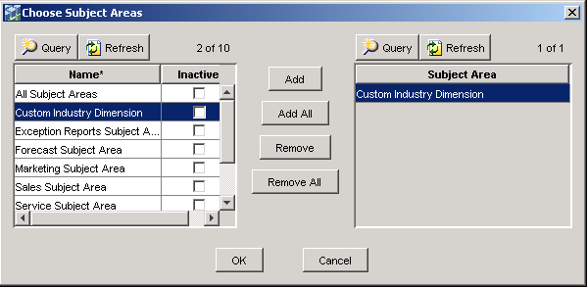
  - Click OK.
  - Click the Database Connections tab in the bottom pane.
  - Confirm the existence of OLAP and OLTP database connections.
  - Click Save in the top pane.
Lab 4-5 Load the Slowly Changing Dimension Table
Goals | To load the slowly changing dimension table using the DAC.
Scenario | You have built the mapping, workflows, and sessions, and DAC tasks are now prepared to load the slowly changing dimension table.
Outcome | The SCD table will be populated.
Time | 15 – 20 minutes
Instructions:
- Query the warehouse tables to determine the number of rows.
  - Select Start > Programs > Microsoft SQL Server > Query Analyzer.
  - In the Connect to SQL Server dialog box, type the following and click OK:
Login name | SIEBEL
Password | SIEBEL
  - Query to determine the number of rows in the Slowly Changing Dimension table.
  - In the Query window, type the following:
SELECT ROW_WID, INDUST_NAME, VERTICAL, SCD_START_DT_WID, SCD_END_DT_WID
FROM OLAP..WC_INDUSTRY_SCD
WHERE INDUST_NAME = 'logging'
  - Select Query > Execute. You should get exactly one row of data with the value of “Consumer Goods” for the VERTICAL column.
  - Leave the Query Analyzer running.
- Update the source table S_INDUST in the Siebel transactional database.
  - Select File > Open.
  - Click No to not save.
  - In the Open Query File dialog box, navigate to C:\Data\ANADW and select the Update_Row_S_INDUST.sql file.
  - Click Open. Examine the SQL here. This SQL updates the foreign key column of a row in the S_INDUST table to point to a different value. This updated row will be inserted as new row during the slowly changing dimension capture process.
  - Select Query > Execute.
  - Ensure the SQL statement executes correctly. The results should be two instances of “1 row(s) affected” and one instance of “1119 row(s) affected”.
- Update the refresh date on the W_INDUSTRY_SCD table in the SRMW. This is to ensure the slowly changing dimension table WC_INDUSTRY_SCD is not truncated during the incremental ETL load.
  - In the DAC client, select Views > Setup > Database Connections.
  - Select the OLAP record on the top pane.
  - Click the Tables bottom pane while OLAP record is selected on the top pane.
  - Click Query button, type WC_INDUSTRY_SCD.
  - Click Go.
  - Click the Refresh Date calendar button for the retrieved WC_INDUSTRY_SCD record.
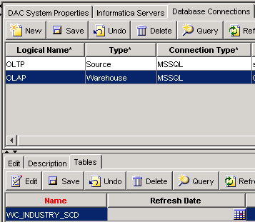
  - Set the Date to August 17, 2005 12:00 AM. This date can be any date earlier than today’s date but set to this particular date shown here for the purpose of this lab.
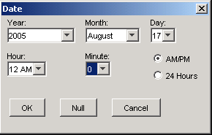
  - Click OK.
  - Click Save to save the changes.
- Run the Custom Industry execution plan from the DAC client.
  - In the DAC client, select Execute in the DAC toolbar or select Views > Execute > Execution Plans (RO).
  - In the Execution Plans tab, select Custom Industry.
  - Click the Run Now button in the Top Pane toolbar.
  - In the Starting ETL dialog box, click Yes to confirm that you want to start the Custom Industry execution plan.
  - Click OK to acknowledge that the request has been successfully submitted to the Informatica Server.
- Monitor the ETL execution plan.
  - Select the Current Run tab or select Views > Execute > Current Run.
  - Select the Custom Industry run and confirm that it has a Task Run Status of Running. Note that the DAC Server Monitor icon has changed from yellow (connected to DAC server) to green, indicating that a plan is being executed.
  - Click Auto Refresh and select 30 seconds from the drop-down list box for automatic refresh frequency.
  - Click OK.
  - Select the Task Details tab in the bottom pane to view task status within the execution plan.
  - In the drop-down menu, select Running to view a list of all running tasks.
  - In the drop-down menu, select All to view a list of all tasks in the execution plan.
  - When all tasks have completed (after approximately 5 minutes), select the Run History Top Pane tab to view the log file for the execution plan you just ran.
    - Select the Custom Industry execution plan you just ran.
    - Right-click the Custom Industry task.
    - Select Get Run information > Get log file.
    - In the Input dialog box, click OK to accept the default log file name.
    - In the Fetching log file dialog box, note the path that the log file has been saved to and click OK.
    - In Windows Explorer, navigate to C:\SiebelAnalytics\DAC\ServerLog\ and open Custom_Industry.<x>.log. The ‘x’ is a system generated number generated assigned by the DAC to this execution plan.
    - Scroll down to the bottom of the file and confirm in the list of step statuses that there are no steps with failed workflows. Even though the log file contains some error message statements, you should see the message “Error Message: Successfully Completed” with the error code return value of “0” at the end.
- Query the warehouse tables to verify the existence of slowly changing dimension rows.
  - Query to retrieve the slowly changing dimension rows.
    - In the Query Analyzer window, select Edit > Clear Window.
    - Type the following:
SELECT ROW_WID, INDUST_NAME, VERTICAL, SCD_START_DT_WID, SCD_END_DT_WID
FROM OLAP..WC_INDUSTRY_SCD
WHERE INDUST_NAME = 'logging'
    - Select Query > Execute. You should get two rows of data. One should contain VERTICAL = Energy. The update you performed to a row in the S_INDUST table in the Siebel transactional database has been captured. The slowly changing dimension process created a new row, which contains the new value for the VERTICAL column, and updated the SCD_END_DT_WID column of the old row with today’s date. If you did not get the expected results, ask your instructor for assistance.
  - Select File > Exit to close Query Analyzer.

